# Ceph 集群监控

Ceph 集群监控 1

一、 Ceph集群监控 2

二、 系统维护 3

1. Prometheus server 3

2. Alertmanager 4

3. Node_exporter 5

4. Ceph-mgr插件 5

5. Grafana-server 5

6. 原生dashoard 6

三、 常见问题 7

1. 新增告警人邮箱 7

2. 屏蔽某条告警 7

3. 修改存储时间 8

4. 修改Prometheus刷新时间 9

5. 新增告警rule 9

四、 自动化脚本安装 10

1. Prometheus安装脚本 10

2. 清除脚本 10

3. Grafana-server安装脚本 11

## Ceph集群监控

Prometheus服务端，定期采集组件信息；根据rules，产生告警信息；

Alertmanager接收Prometheus服务端产生的告警事件，告警事件处理、邮件告警输出；

Node_exporter采集服务器物理信息（磁盘、内存、CPU、网络）；

Ceph-mgr的插件监控Ceph集群；

Grafana提供大屏展示，轮询dashboard，历史数据查看，图表展示。

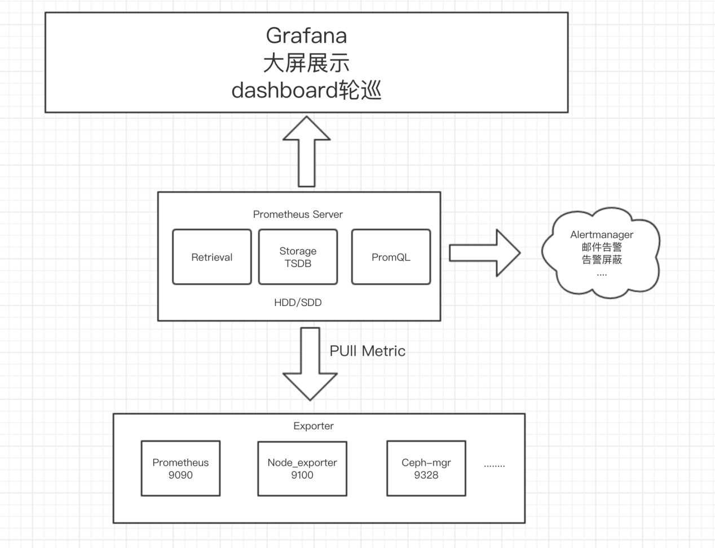

## 系统维护

### Prometheus server

(1)服务检查：

服务状态：(状态、启动、重启)

systemctl status/start/restart prometheus

端口9090：

netstat -nltp|grep 9090

(2)配置文件：

[root@node1 prometheus]# cat /usr/local/prometheus/prometheus/prometheus.yml

# my global config

global:

scrape_interval: 15s # Set the scrape interval to every 15 seconds. Default is every 1 minute.

evaluation_interval: 15s # Evaluate rules every 15 seconds. The default is every 1 minute.

# scrape_timeout is set to the global default (10s).

# Alertmanager configuration

alerting:

alertmanagers:

- static_configs:

- targets: ['10.127.7.80:9093']

# Load rules once and periodically evaluate them according to the global 'evaluation_interval'.

rule_files:

- "ceph_default_alerts.yml"

- "node_alerts.yml"

# A scrape configuration containing exactly one endpoint to scrape:

# Here it's Prometheus itself.

scrape_configs:

- job_name: 'prometheus'

static_configs:

- targets: ['10.127.7.80:9090']

- job_name: 'ceph'

static_configs:

- targets: ['10.127.7.80:9283']

- job_name: 'node-exporter'

static_configs:

- targets: ['10.127.7.80:9100']

### Alertmanager

1. 服务检查：

服务状态：(状态、启动、重启)

systemctl status/start/restart alertmanager

端口9093：

netstat -nltp|grep 9093

(2)配置文件：

[root@node1 alertmanager]# cat `pwd`/alertmanager.yml

global:

smtp_smarthost: 'smtp.163.com:465'

smtp_from: '18611305335@163.com'

smtp_auth_username: '18611305335@163.com'

smtp_auth_password: xxxxxx

smtp_require_tls: false

templates:

- '/etc/alertmanager/template/*.tmpl'

# The root route on which each incoming alert enters.

route:

group_by: ['alertname', 'cluster', 'service']

group_wait: 3s

group_interval: 10s

repeat_interval: 3m

receiver: team-X-mails

receivers:

- name: 'team-X-mails'

email_configs:

- to: 'zhangkai5565@fiberhome.com'

send_resolved: true

tls_config:

insecure_skip_verify: true

以上邮件告警接收人的配置、时间等待、告警策略等

### Node_exporter

(1)服务检查：

服务状态：(状态、启动、重启)

systemctl status/start/restart node_exporter

端口9100：

netstat -nltp|grep 9100

1. 无配置文件，只采集数据，等待prometheus pull

### Ceph-mgr插件

ceph -s查看是否有该module （prometheus）的异常告警

Ceph mgr services查看服务是否启动

[root@node1]# ceph mgr services

{

"prometheus": "http://node1:9283/"

查看端口是否正常

[root@node1 alertmanager]# netstat -antup|grep 9283

### Grafana-server

(1)服务检查：

服务状态：(状态、启动、重启)

systemctl status/start/restart grafana-server

端口3000：

netstat -nltp|grep 3000

配置文件

[root@node1 alertmanager]# cat /etc/grafana/grafana.ini

[smtp]

enabled = true

host = smtp.163.com:465

user = xxx@163.com

password =xxx

skip_verify = true

from_address = 18611305335@163.com

from_name = Grafana

[emails]

[log]

[log.console]

[log.file]

[log.syslog]

[alerting]

enabled = true

execute_alerts = true

[explore]

[metrics]

[metrics.graphite]

[tracing.jaeger]

[grafana_com]

[external_image_storage]

[external_image_storage.s3]

[external_image_storage.webdav]

[external_image_storage.gcs]

[external_image_storage.azure_blob]

[external_image_storage.local]

[rendering]

[enterprise]

[panels]

### 原生dashoard

ceph -s查看是否有该module （dashboard）的异常告警

Ceph mgr services查看服务是否启动

[root@node1]# ceph mgr services

{

"dashboard": "https://node1:8443/",

查看端口是否正常

[root@node1 alertmanager]# netstat -antup|grep 8443

## 常见问题

### 新增告警人邮箱

修改/usr/local/prometheus/alertmanager/alertmanager.yml，在收件人里加上新的收件人：

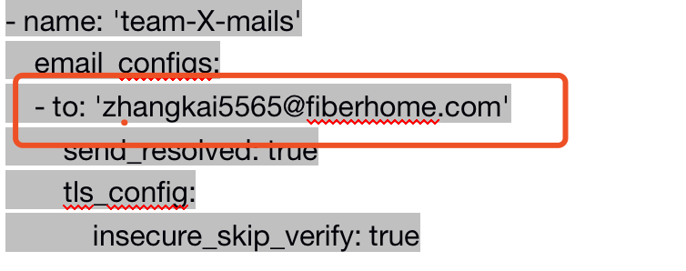

然后重启服务

Systemctl restart alertmanager.service

### 屏蔽某条告警

打开9093端口，设置该条告警的silence

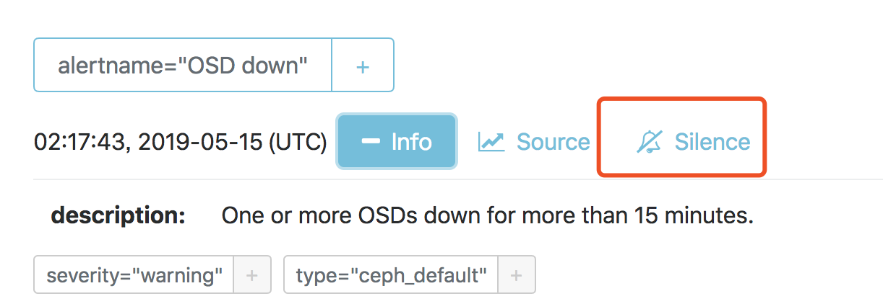

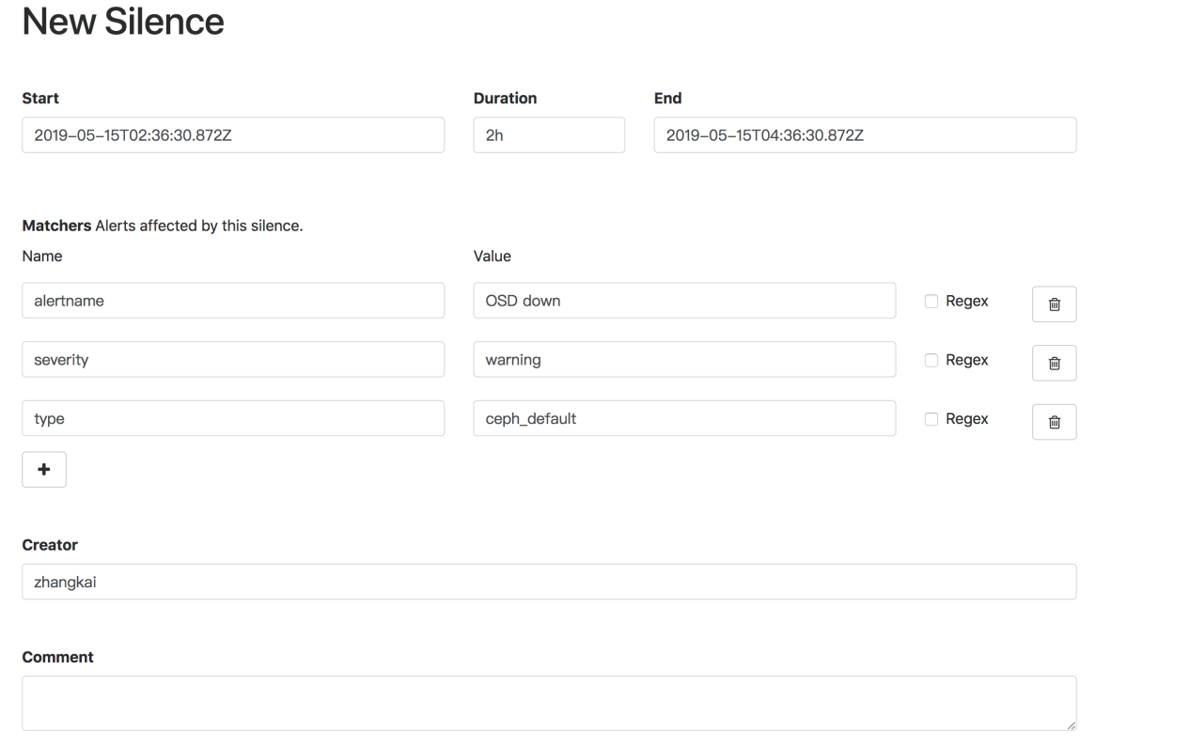

### 修改存储时间

修改启动项配置

[root@node1 alertmanager]# cat /usr/lib/systemd/system/prometheus.service

[Unit]

Description=prometheus

After=network.target

[Service]

Type=simple

User=prometheus

ExecStart=/usr/local/prometheus/prometheus/prometheus --config.file=/usr/local/prometheus/prometheus/prometheus.yml --storage.tsdb.path=/var/lib/prometheus --storage.tsdb.retention=30d

Restart=on-failure

[Install]

WantedBy=multi-user.targe

如下：

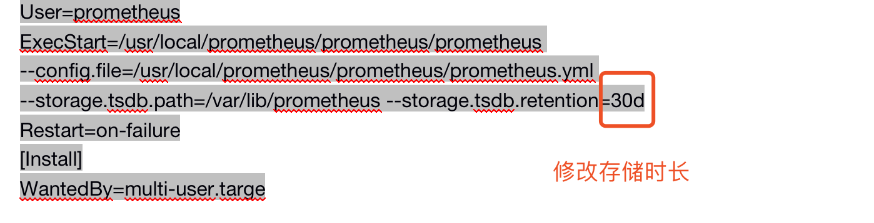

然后执行

systemctl daemon-reload

Systemctl restart prometheus

### 修改Prometheus刷新时间

Vim /usr/local/prometheus/prometheus/prometheus.yml

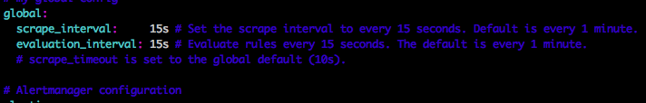

修改上图时间

然后执行

Systemctl restart prometheus

### 新增告警rule

Vim /usr/local/prometheus/prometheus/prometheus.yml

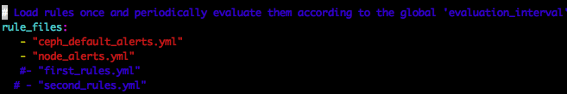顺序添加

然后执行

Systemctl restart prometheus

## 自动化脚本安装

### Prometheus安装脚本

#!/bin/bash

read -p "server or node:" node

useradd prometheus

if [ "$node"x = "node"x ];then

cp system/node_exporter.service /usr/lib/systemd/system/

systemctl enable node_exporter

systemctl start node_exporter

echo "install node_exporter sucess"

exit 0

fi

mkdir -p /var/lib/prometheus/alertmanager/data

cp system/* /usr/lib/systemd/system/

chown -R prometheus:prometheus /var/lib/prometheus/

chown -R prometheus:prometheus /usr/local/prometheus/

systemctl enable alertmanager

systemctl start alertmanager

systemctl enable node_exporter

systemctl start node_exporter

systemctl start prometheus

ln -s /usr/lib/systemd/system/prometheus.service /etc/systemd/system/multi-user.target.wants/

echo "install alertmanager node_exporter prometheus sucess"

### 清除脚本

#!/bin/bash

systemctl stop alertmanager

systemctl stop node_exporter

systemctl stop prometheus

rm -rf /var/lib/prometheus

rm -rf /usr/lib/systemd/system/alertmanager.service

rm -rf /usr/lib/systemd/system/node_exporter.service

rm -rf /usr/lib/systemd/system/prometheus.service

userdel prometheus

echo "uninstall alertmanager node_exporter prometheus sucess"

### Grafana-server安装脚本

#!bin/bash

yum localinstall grafana -y

unzip Vonage-Grafana_Status_panel-v1.0.9-4-g2a9b8e1.zip

sleep 3

unzip grafana-piechart-panel-cf03cdf.zip

sleep 3

mv Vonage-Grafana_Status_panel-2a9b8e1 /var/lib/grafana/plugins/vonage-status-panel

mv grafana-piechart-panel-cf03cdf/ /var/lib/grafana/plugins/grafana-piechart-panel

ls /var/lib/grafana/plugins/grafana-piechart-panel

grafana-cli plugins ls

systemctl start grafana-server

systemctl enable grafana-server

systemctl status grafana-server